Project Title: Personal Expense Tracker Application Project Design Phase-I - Solution Fit Template Team ID: PNT2022TMID07838

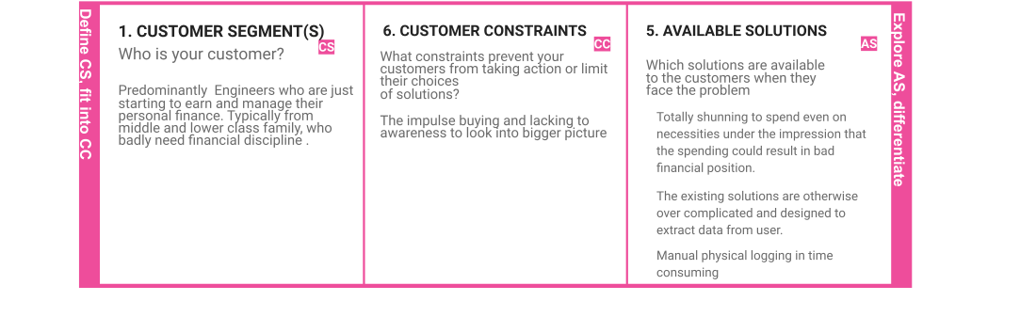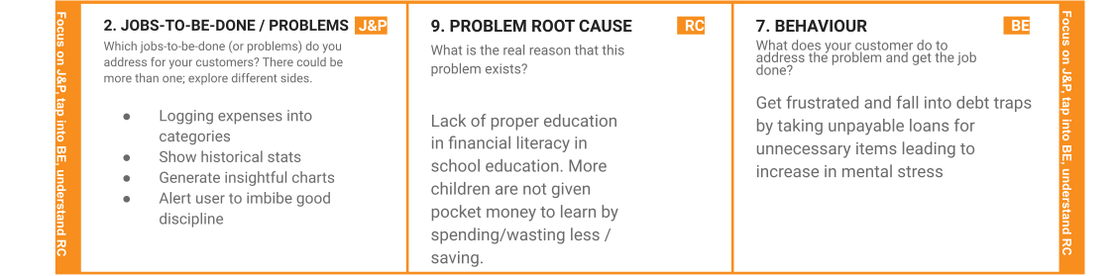

|  |  |  |  |  |
| --- | --- | --- | --- | --- |
|  | **3. TRIGGERS TR**  What triggers customers to act? Frequent sales in e-commerce platforms and seamless shopping experience  online. | **10. YOUR SOLUTION SL**  If you are working on an existing business, write down your current solution ﬁrst, ﬁll in the canvas, and check how much it ﬁts reality.  If you are working on a new business proposition, then keep it blank until you ﬁll in the canvas and come up with a solution that ﬁts within customer limitations, solves a problem and matches customer behavior.  Graphical Application with simple UI and to the point clutter free objective. Avoids provision to pay through the app, to minimize the spending and ensure that only necessary spendings are made. The aim is to make the spending process harder throughout the application and keep it clean. | 1. **CHANNELS of BEHAVIOUR CH**    1. **ONLINE**   What kind of actions do customers take online? Extract online channels from #7   * + 1. Shop from e-commerce     2. Subscribe to OTT platforms     3. Order food frequently   1. **OFFLINE**   What kind of actions do customers take ofﬂine?  Extract ofﬂine channels from #7 and use them for customer development.   * + 1. Shop in malls during sales     2. Keep the money somewhere around and forget about /lose it |  |
| **4. EMOTIONS: BEFORE / AFTER EM** How do customers feel when they face a problem or a job and afterwards?  Dejected and paranoid about the future as they would need relatively more money to provide for a family and to handle unexpected ﬁnancial needs. |

